

P1-Pothole Tracking and Repair

Prasant Kumar (2018MB12036)

Kulsharest Jain (2018MB12006)

Navneet Thillaisthanam (2018MB12030)

Nishant Kumar (2018MB12016)

**INDEX**

1. Project: P1 - Pothole Tracking and Repair 4

1.1. Requirement: 4

2. Identify Actors and Use Cases 4

2.1. UC01 - Login and Authentication: 4

2.2. UC02 - Report Pothole 4

2.3. UC03 – Assign Pothole 4

2.4. UC04 - Work Progress and Tracking 4

2.5. UC05 - Review and Feedback 5

2.6. UC06 - Release Payment 5

3. Fully Dressed Use Cases 7

3.1. UC1: Login and Authentication 7

3.2. UC2: Report Pothole 9

3.3. UC3: Assign Pothole 12

3.4. UC4: Work Progress and Tracking 15

3.5. UC5: Review and Feedback 17

4. System Contracts 19

4.1. Contract C01: Login 19

4.2. Contract C02: Report Pothole 19

5. Interaction Diagram 20

5.1. Login Interaction Diagram 20

5.2. Report Pothole Interaction Diagram 20

6. Design Class Model 21

7. Package Diagram: 22

8. User Interface Mock Ups 22

8.1. Login screen 22

8.2. Report Pothole 24

8.2.1. Gathering Pothole Information 24

8.2.2. Flow Diagram of user interface 24

9. Appendix 1 – Iteration 3, review comments and changelog 25

**Revision Control**

|  |  |  |  |
| --- | --- | --- | --- |
| **Revision No.** | **Reason for Change** | **Revision Date** | **Changes Done** |
| V1.0 | First Draft Of Project | 20/10/2018 | UC Identification, and 2 UC Fully Dressed |
| V2.0 | Iteration 2 | 16/11/2018 | * System Operation Contracts * Interaction diagrams between objects - Sequence * Domain Class Design * User Interface Prototype - sketches - hand or with a tool |
| V3.3 | Iteration 3 | 27/12/2018 | * Updates from feedback review (see appendix 1) * Login page designed and added diagrams * Added use-case UC03-06; terse and fully-dressed format * Added Activity & Package Diagram * State chart Diagram update. |
|  |  |  |  |
|  |  |  |  |

**Reference:**

UML Book: Applying UML and Patterns 3rd edition

UML Tool: StarUML

User Interface Prototype tool: mockplus

## Project: P1 - Pothole Tracking and Repair

## Requirement:

Bangalore Mayor has promised to repair all the potholes in the city with citizen participation. You are IT implementation partner to BBMP for web based or smartphone app based (or both) Pothole Tracking and Repair system. Citizens will report the potholes with a GPS Map location and a photograph. BBMP will assign pothole repair work to a Contractor. Contractor will provide a cost estimate along with a photograph and size confirmation of the pothole. The software will calculate the pothole size from photograph and cross check with the details submitted by Contractor. BBMP will approve the cost estimate and Contractor will perform the work. Citizen who have reported pothole will be able to report their satisfaction on repair work. Contracts will be assigned by area - constituency / wards / pin code. Contractor will be paid on a monthly basis. A Google Map integrated navigation of potholes with their status will be provided. The Mayor should be able to visualize the progress for overall city or by an area - constituency / pin code or by individual roads.

## Identify Actors and Use Cases

## UC01 - Login and Authentication:

**Actors:** Citizen, BBMP, Contractor

**Use Case:** System shall have login/logout feature for all users and for accessing the system, a user has to input login credentials, comprising of a UserID and password. While creating profile of Citizen and Contractor, the system shall have personal details of the user. BBMP shall have admin rights to make changes in data stored in the system.

## UC02 - Report Pothole

**Actors:** Citizen

**Use Case:** The Citizens report the potholes with a GPS Map location and a photograph of the pothole. A Google Map will be integrated for reporting pothole

## UC03 – Assign Pothole

**Actors:** BBMP, Contractor

**Use Case:** BBMP will assign pothole repair work to a Contractor. Further, the contractor will provide a cost estimate based on the size of the pothole. The software will automatically calculate the pothole size from photograph and cross check with the details submitted by Contractor. BBMP will approve the cost estimate and the contractor will perform the work assigned. Contracts will be assigned by area - constituency / wards / pin code. The contractor will be paid on a monthly basis.

## UC04 - Work Progress and Tracking

**Actors:** Citizen, BBMP, Contractor

**Use Case:** Citizens/BBMP/Contractors can track their request with unique Request ID generated by the system. With navigation of potholes, their status will be provided. The Mayor should be able to visualize the progress for overall city or by an area - constituency / pin code or by individual roads.

## UC05 - Review and Feedback

**Actors:** Citizen, BBMP, Contractor

**Use Case:** BBMP can review work quality and provide feedback to the Contractor.Citizen who have reported pothole will be able to report their satisfaction on repair work, with review and feedback. BBMP can reassign work to the contractor (Or another Contractor).

## UC06 - Release Payment

**Actors:** Contractor, BBMP

**Use Case:** BBMP pays the cumulative cost of all potholes fixed in a month to contractors that are marked as completed. Payment is initiated by the BBMP and are routed through a payment gateway. Upon successful confirmation from the payment gateway, the accounting systems of BBMP are updated for reporting expenses.

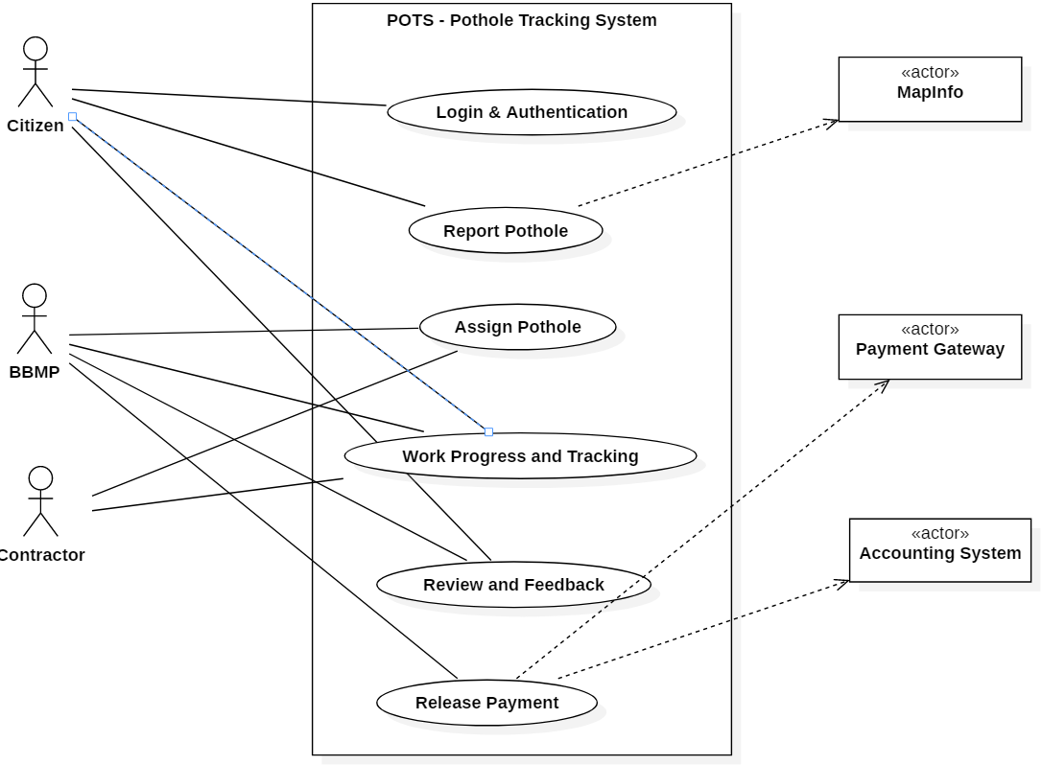

**Partial use-case context diagram**

## Fully Dressed Use Cases

## UC1: Login and Authentication

**Scope:** Pothole Tracking and Repair System Login

**Level:** User goal

**Primary Actors:** Citizen, BBMP, Contractor

**Stakeholder and Interests:**

-Citizen, BBMP, and Contractor: wants fast and easy login/logout process. While capturing personal details minimum required fields should be mandatory. Easily able to tag the location of pot hole with longitude and latitude in the application.

-System: should provide easy process for reset and forget Password, access to camera and google database and user-friendly multi-lingual interface.

-BBMP: wants admin rights to modify any user request data or user data itself.

- Authentication: should be fast and always return correct result.

**Preconditions:** User profile must be created for successful login/logout

**Success Guarantee:** User is logged into the system and the based on the role of the user, services and features are made available to the user.

**Main success scenario (MSS):**

1. User accesses the URL/APP.
2. The system prompts the user for their login page/display.
3. The user enters his/her credentials - UserId and Password.
4. The system authenticates the user.
5. System display message: “Successfully logged-in”
6. The user gains access to the systems functionality.
7. Users can logout by using logout button.
8. System logged out and display popup message: “Successfully logged out”

**Extensions (or Alternative Flow):**

*a User profile creation.

1. For a new user, the system should provide an option for creating a new profile.

2. User name must be unique.

3. User shall input a user name of his/her choice.

4. User can choose any password of his/her choice.

5. User can verify the password by typing it again.

6. System checks, if the user name is not already in use.

7. System checks, if the two passwords are identical

8. System registers the new user with the credentials generated such as user name, password

6a. User name is already in use

1. User is requested to select another user name and password

7a. The two passwords are different

1. User is requested to retype (twice) his/her password

9. All personal data required to fill while creating new user profile. Name (First, Last & Middle), Mobile No, Full Address, Email-ID and DOB should be mandatory fields.

10. Location service if being used in app or web page should provide state, locality automatically during new profile creation.

**Extensions**

4b. Reset password.

1. System should provide reset password functionality is user forget password.

2. If reset password is requested, a level of authentication must be required, such as OTP on mobile or reset link in e-mail of user, as the case like.

4c. BBMP admin rights

1. BBMP user can see the registered users, and data will be modifying using admin rights

**Class Diagram:**

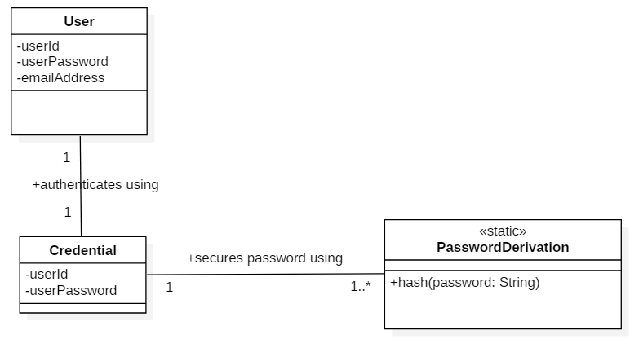

**SSD:**

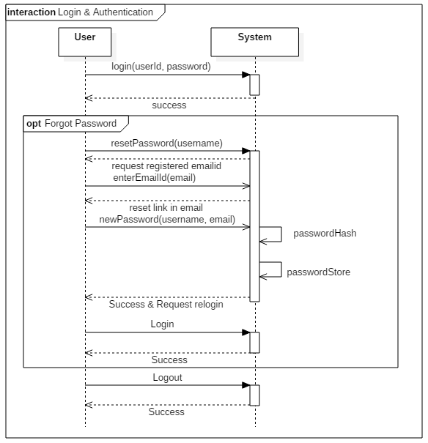

**State chart Diagram:**

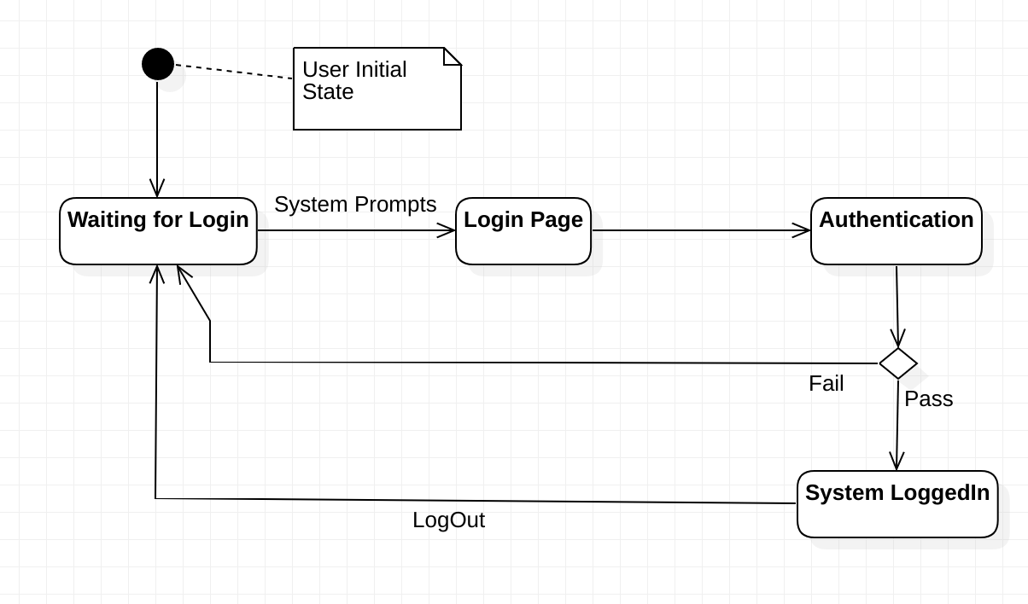

**Activity Diagram:**

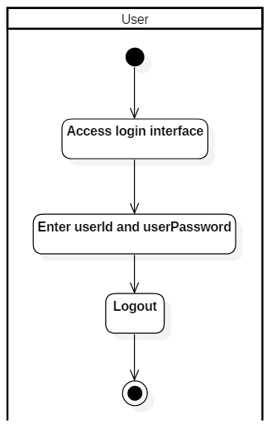

## UC2: Report Pothole

**Scope:** Pothole Report

**Level:** User goal

**Primary Actors:** Citizen

**Stakeholder and Interests:**

- Citizen: wants easy option to report pothole, map should be integrated while reporting. After report a unique ID should be generated for tracking

- System: should identify unique request and assigned a unique ID for identification of pothole.

**Preconditions:** Citizen must be logged in.

**Success Guarantee:** After successful creation of request a unique ID for the pothole, potholeId, should generated.

**Main success scenario (MSS):**

1. Citizen require adding pothole details like address, landmark, GPS location, photos, and pothole criticality.

2. The citizen needs to tag GPS location of pothole on Google Map.

3. The citizen needs to create request by clicking a submit button

4. System will generate unique ID.

**Extensions (or Alternative Flow):**

*a. If system logged out user, System will system shall allow login again.

*1a2a. In case the citizen cannot locate the pothole on the Google maps service, he/she shall have the ability to enter the pothole address (including pincode).

3a. User can save its request and submit later. User can re-login and again open it older saved request and submit.

**Class Diagram:**

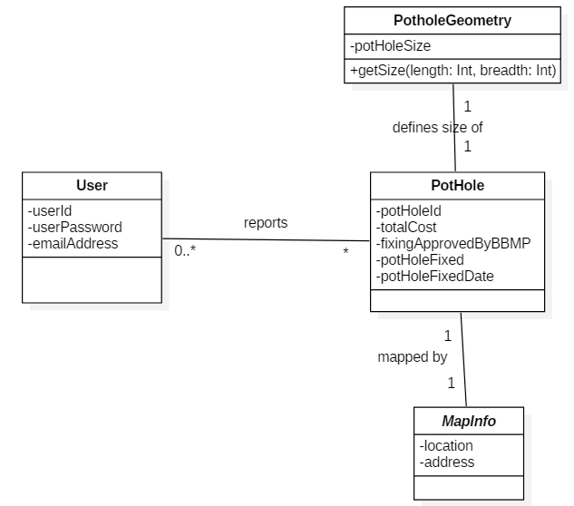

**SSD:**

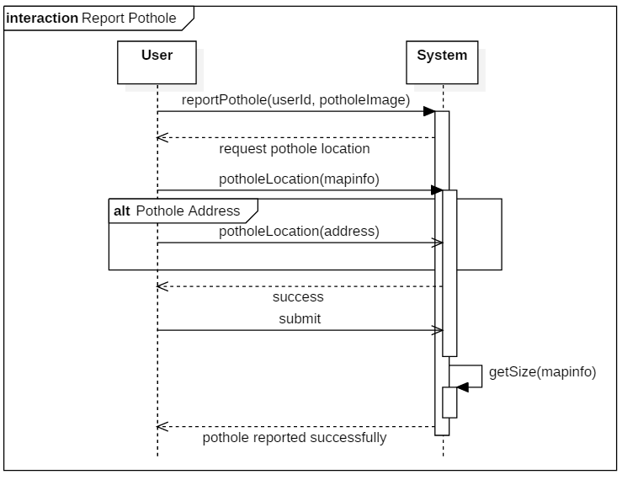

**State chart Diagram:**

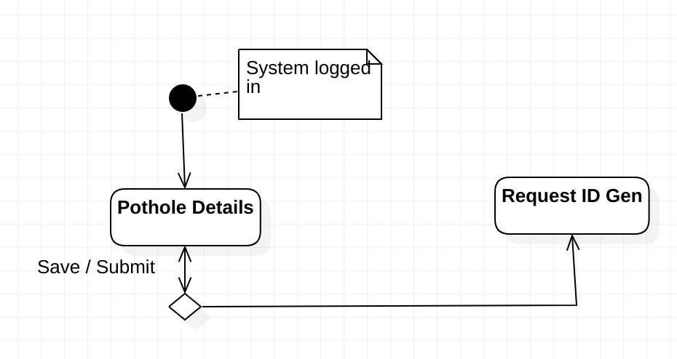

**Activity Diagram**:

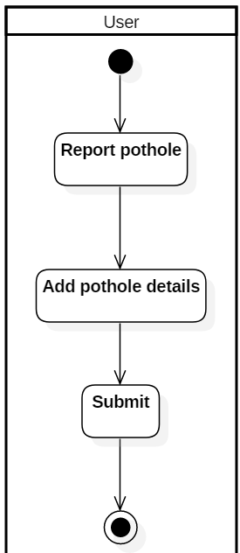

## UC3: Assign Pothole

**Scope:** Assign Pothole

**Level:** User goal

**Primary Actors:** BBMP, Contractor

**Stakeholder and Interests:**

-BBMP: With unique ID BBMP can assign work to contractor.

-System: System shall able to calculate size of pothole from photos.

-Contractor: Shall able to provide cost estimation of pothole

**Preconditions:** Pothole request must be created, and unique ID must be generated. Valid contractor must be available.

**Success Guarantee:** Work will be assigned to contractor.

**Main success scenario (MSS):**

1. BBMP will login to system and check for new pothole request

2. New request will be assign to Contractor on basis of constituency / wards / pin code of request pothole.

3. Contractor will login to get new assignment.

4. Contractor will provide cost estimate based on the size of the pothole.

5. System will calculate cost on basis of size and photos.

6. BBMP will review both cost and approve work and cost to Contractor.

**Extensions (or Alternative Flow):**

*a. If system logged out user, System will allow again to login.

2a. In case of contractor not found in constituency / wards / pin code, BBMP will request to new contractor.

5a. In case of system not able to calculate cost of assignment, BBMP can fix cost for work assignment.

6a. In case cost provided by contractor is not approved by BBMP, BBMP can re-assign work to other contractor.

**Class Diagram:**

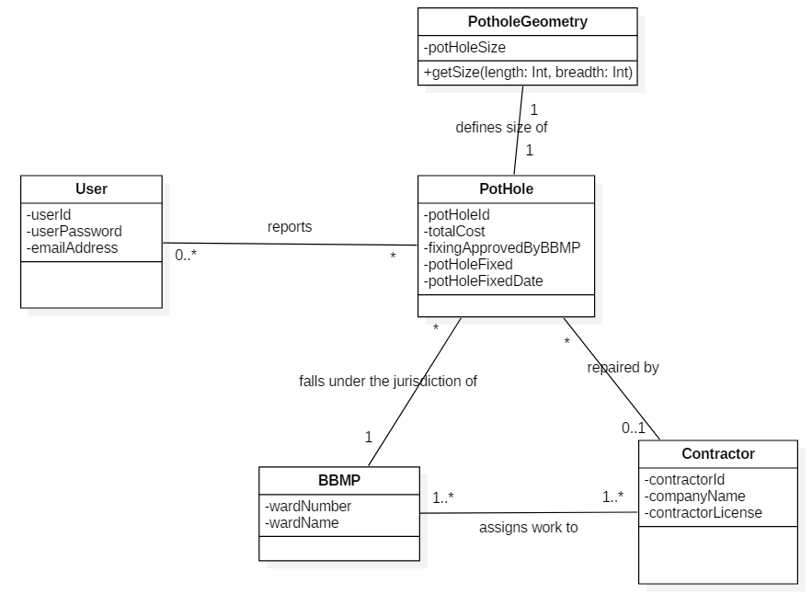

**SSD:**

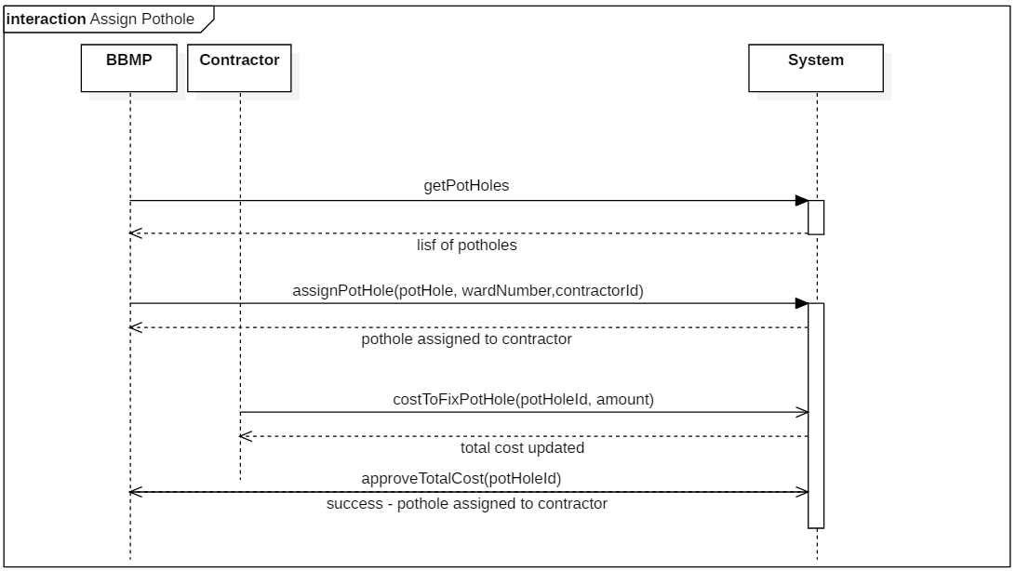

**State chart Diagram:**

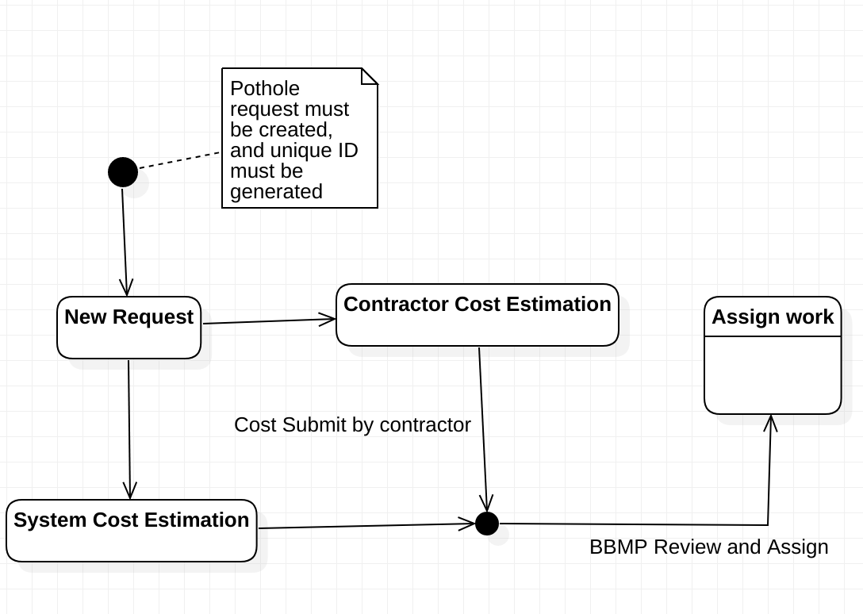

**Activity Diagram:**

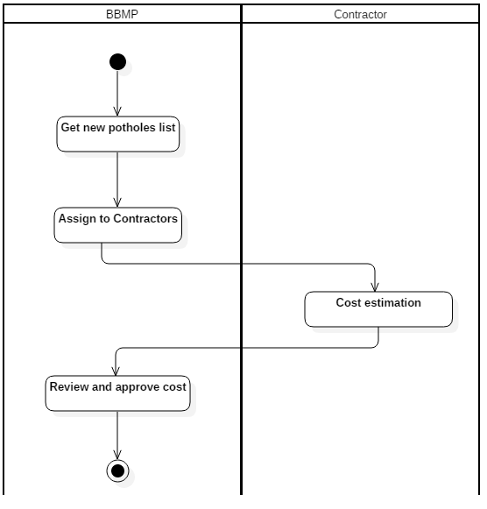

## UC4: Work Progress and Tracking

**Scope:** Work Progress and tracking

**Level:** User goal

**Primary Actors:** Citizen, BBMP, Contractor

**Stakeholder and Interests:**

-BBMP: With unique ID BBMP can track assigned work to contractor.

-System: System shall able to navigate pothole and its status

-Contractor: Shall able to get status of its work.

-Citizen: With unique ID Citizen can track work to progress.

**Preconditions:** Pothole request must be created, and unique ID must be generated. Work must be assigned to contractor.

**Success Guarantee:** Work progress can be tracked by User/BBMP/Contractor.

**Main success scenario (MSS):**

1. Citizens/BBMP/Contractors need to login to get tracking of work.

2. Citizens/BBMP/ Contractors need to enter unique request ID.

3. System will give information related to unique request ID

4. System will give navigation of potholes, their status.

5. System must allow to see all work assignment by an area - constituency / pin code or by individual roads.

**Extensions (or Alternative Flow):**

*a. If system logged out user, System will allow again to login.

2a. If request ID is not valid system prompt error message. And re-allow to enter new request ID.

**Class Diagram:**

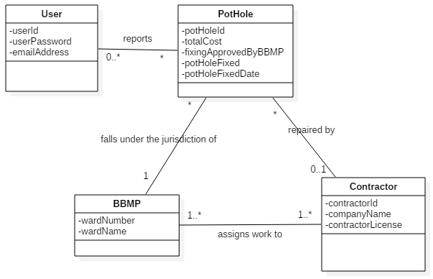

**SSD:**

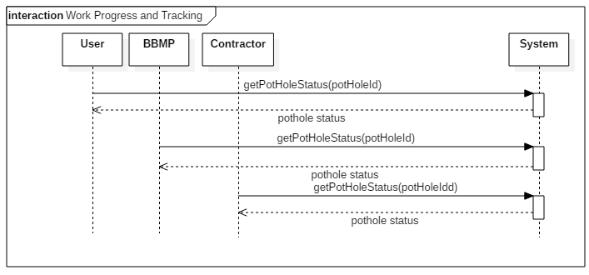

**Activity Diagram:**

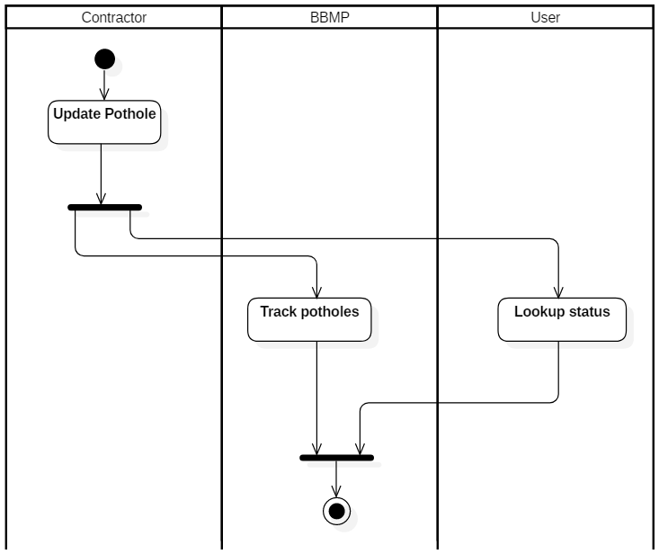

## UC5: Review and Feedback

**Scope:** Review and Feedback

**Level:** User goal

**Primary Actors:** Citizen, BBMP, Contractor

**Stakeholder and Interests:**

-BBMP: With unique ID BBMP can check quality of work and feedback to Contractor.

-Citizen: With unique ID Citizen can review its request and feedback.

**Preconditions:** Pothole request must be created, and unique ID must be generated. Work must be assigned to contractor and finished.

**Success Guarantee:** Work review and feedback can be given by Citizen/BBMP.

**Main success scenario (MSS):**

1. Citizens/BBMP/Contractors need to login to get work review status and feedback.

2. Citizens/BBMP/ Contractors need to enter unique request ID.

3. System will provide feedback and review window to enter comments and rating.

4. System will provide feedback and review window to contractor to see its work status.

5. System must allow to re-assign work to other Contractor.

**Extensions (or Alternative Flow):**

*a. If system logged out user, System will allow again to login.

2a. If request ID is not valid system prompt error message. And re-allow to enter new request ID.

## System Contracts

## Contract C01: Login

**Operation**: login (username:String, password:String)

**Cross References**: Use case: UC01: Login and Authentication

**Preconditions**: A user is registered

**Postconditions**:

* User credential object created.
* Password is hashed using the systems’ hashing function
* User provided password hash is compared to the one stored in the system
* User logged on if passwords match
* Previous reported pothole information is loaded if platform is mobile

## Contract C02: Report Pothole

**Operation**: reportPothole(userId: Int, address:String, potholeImage:Binary)

**Cross References**: Use case: UC02: Report Pothole

**Preconditions**: A user is registered and logged in

**Postconditions**:

* A new pothole object was created
* Pothole status set to ***Reported***.
* Pothole GPS coordinates was captured from Map metadata
* Pothole associated with a ward where the work must be done
* Pothole size was calculated and added to the pothole object
* Pothole associated with the user

## Interaction Diagram

## Login Interaction Diagram

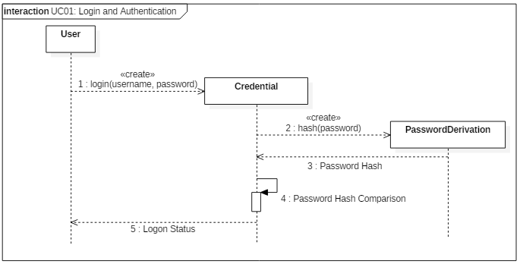

## Report Pothole Interaction Diagram

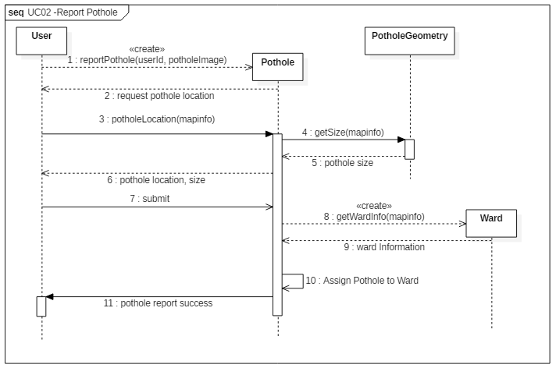

## Design Class Model

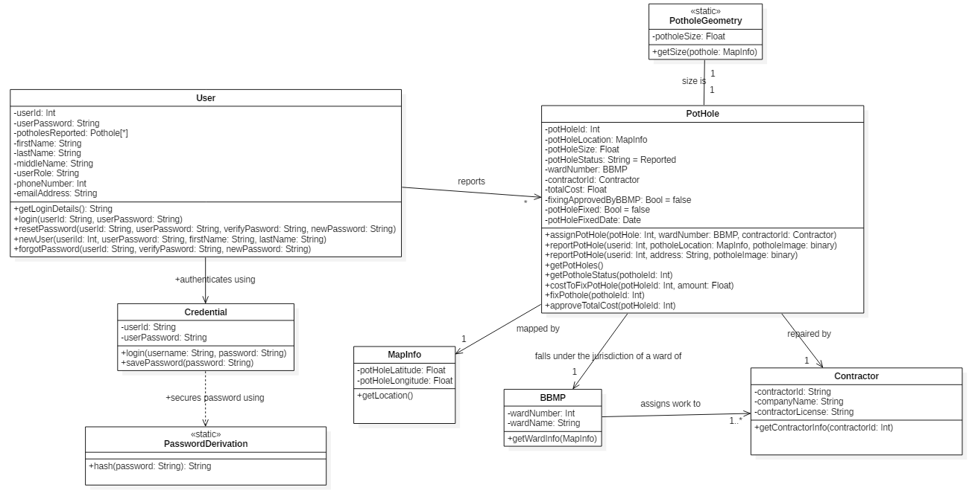

## Package Diagram:

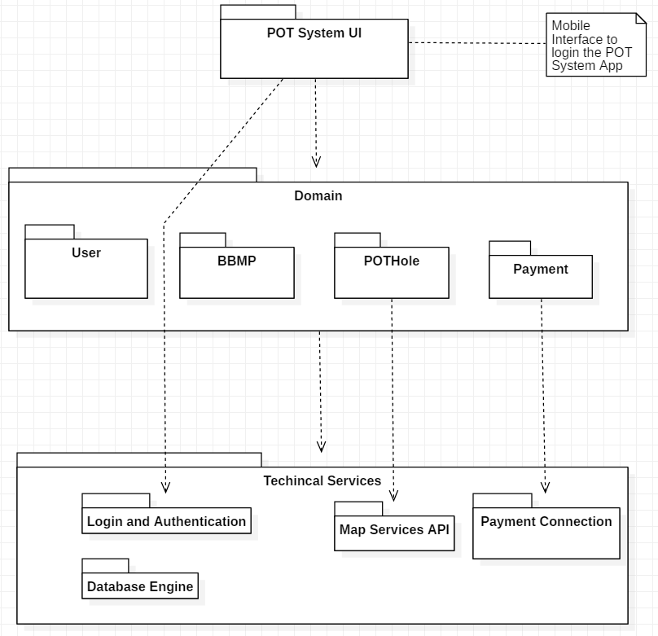

## User Interface Mock Ups

## Login screen

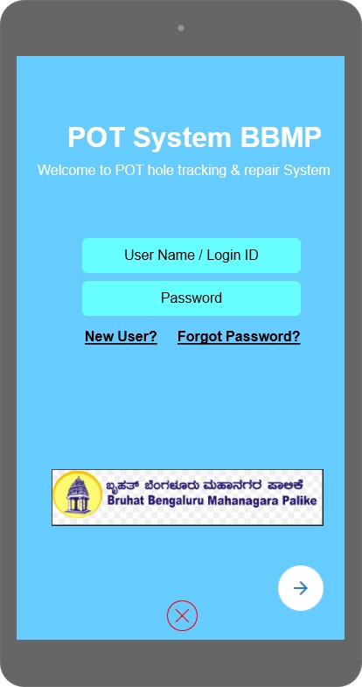 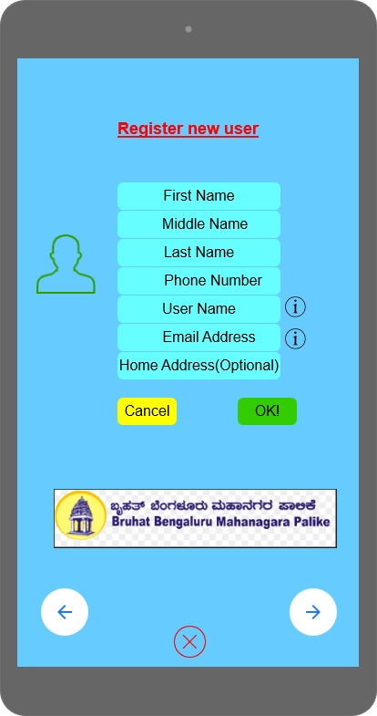

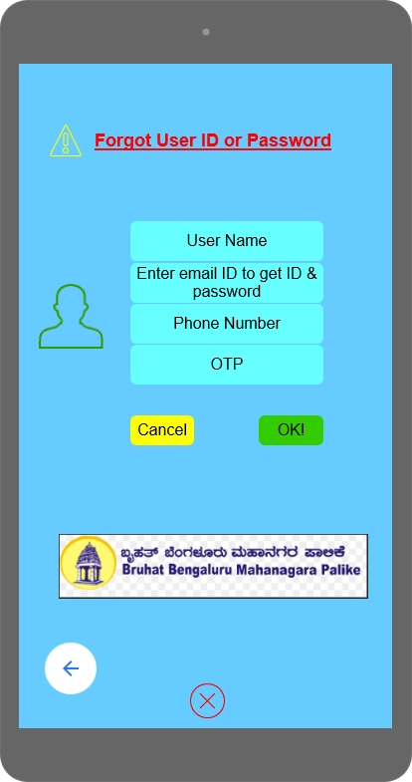

## Report Pothole

## Gathering Pothole Information

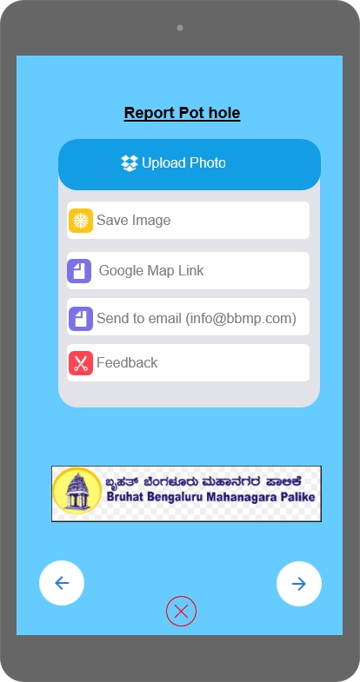 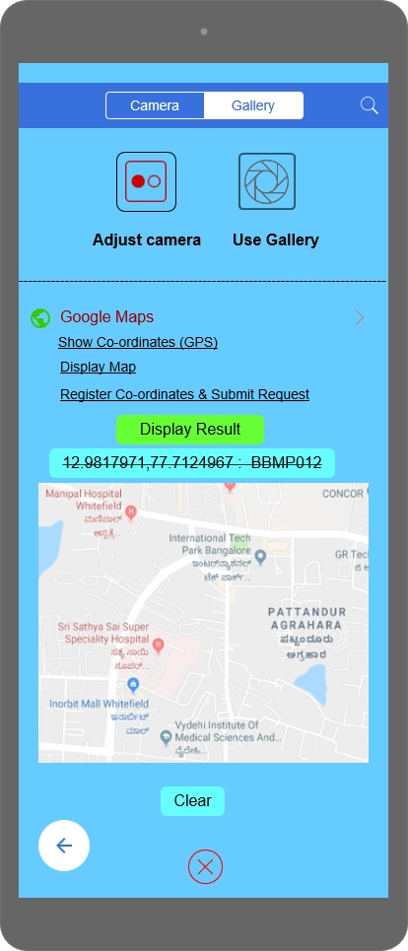

## Flow Diagram of user interface

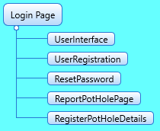

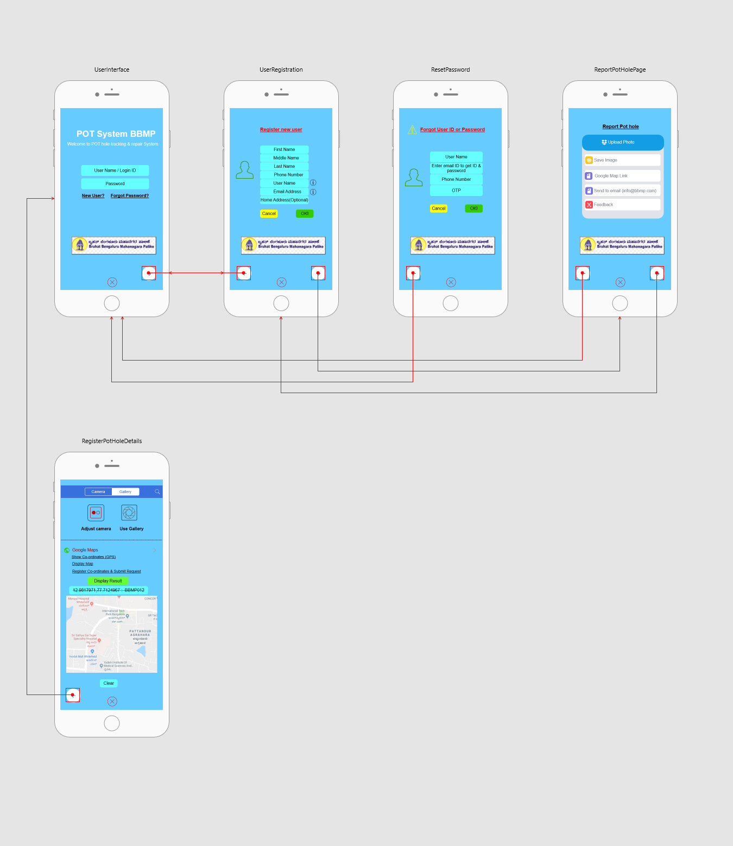

## Appendix 1 – Iteration 3, review comments and changelog

* 1. Added external actors to use-case context diagram
  2. Added login page diagrams and user interface
  3. Added brief format use-case for the *Release Payment* use-case (UC06)
  4. Changed Domain Class Diagram format to Contextual Domain Model in UC01
  5. Corrected System Sequence Diagram for UC01
  6. Changed Domain Class Diagram format to Contextual Domain Model in UC02
  7. Corrected System Sequence Diagram for UC02
  8. Minor updates to operations contracts
  9. Updates/corrections to Interactions Diagrams for the use-cases
  10. User interface prototypes changed